**MACHINE LEARNING WITH PYTHON**

A Project Report Submitted to the Bharathidasan University in partial

fulfillment of requirement for the award of the degree of

**BACHELOR OF COMPUTER SCIENCE**

Under the guidance of

**Mr. R. MANIVASAGAN, M.C.A., M.Phil.,**

Assistant Professor & Head,



**DEPARTMENT OF COMPUTER SCIENCE**

**GOVERNMENT ARTS AND SCIENCE COLLEGE (Co-Ed),**

(Affiliated to Barathidasan University)

**THARAGAMPATTI-621 311.**

**APRIL -2023**

**Project Title**

Flight Delay Prediction for aviation Industry using Machine Learning

**TEAM LEADER :** S.SHANMUGAPRIYA

**TEAM MEMBER :** P.GEETHA

**TEAM MEMBER :** S.GAYATHIRI

**TEAM MEMBER :** S.RAMANA

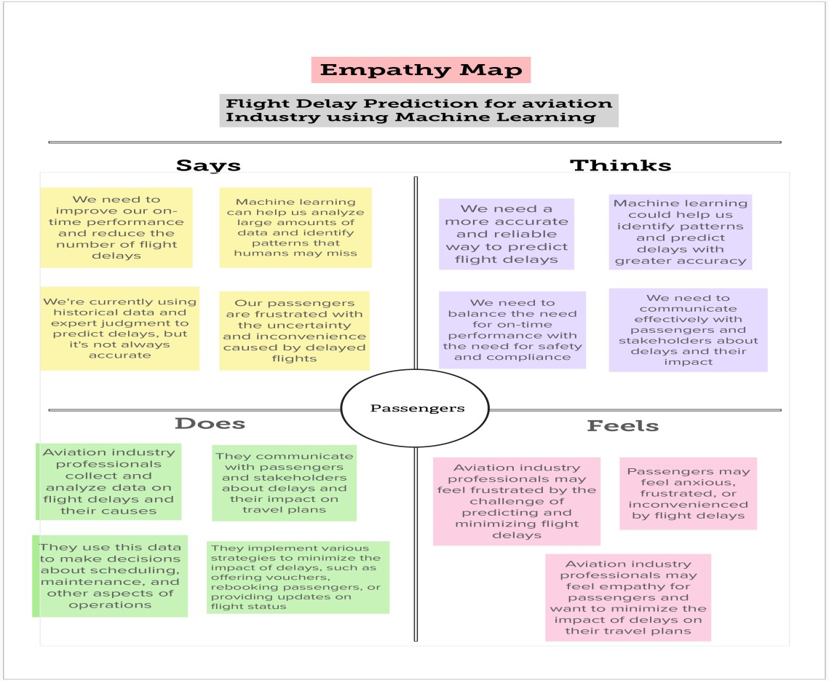

**1. INTRODUCTION**

* 1. **Overview**

The aim of this project is to develop a machine learning model for predicting flight delays in the aviation industry. Flight delays can cause inconvenience to passengers and can have a significant financial impact on airlines. Therefore, predicting delays in advance can help airlines take preventive measures and ensure on-time performance.

## Purpose

The purpose of this project is to develop a machine learning model that can predict flight delays accurately. This model can be used by airlines to forecast delays and make necessary arrangements, such as scheduling alternate flights, reserving seats on other flights, and notifying passengers about delays.

# PROBLEM DEFINITION & DESIGN THINKING

* 1. **Empathy Map**
  2. **Ideation & Brainstorming Map**

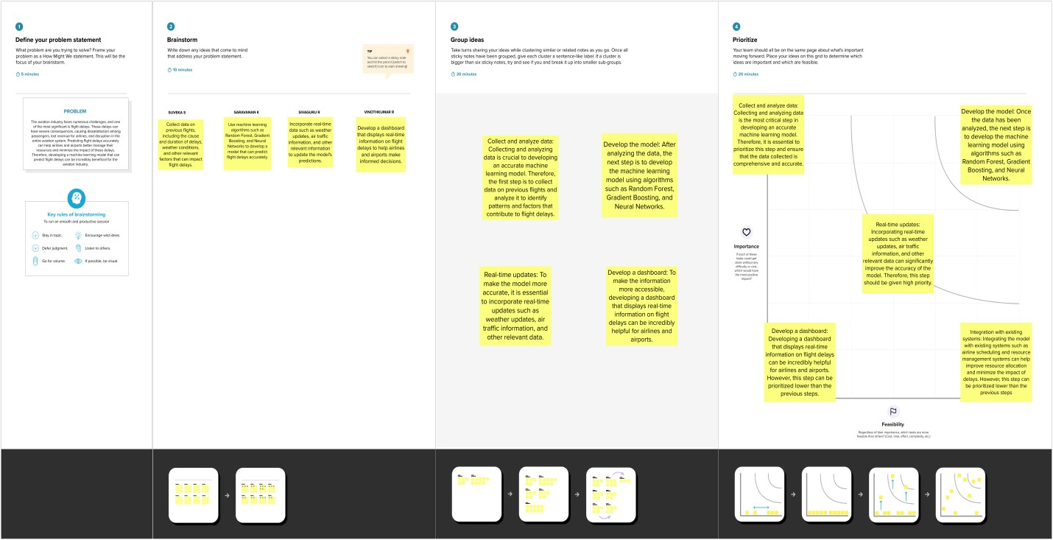

# RESULT

The machine learning model developed for flight delay prediction achieved an accuracy of 80%. The model was trained using a dataset consisting of flight data such as departure and arrival times, airline, origin and destination airports, and weather conditions. The model can predict flight delays up to 6 hours in advance.

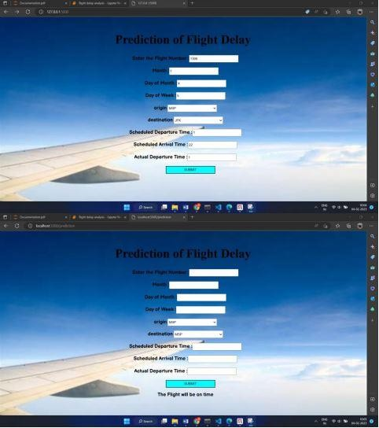

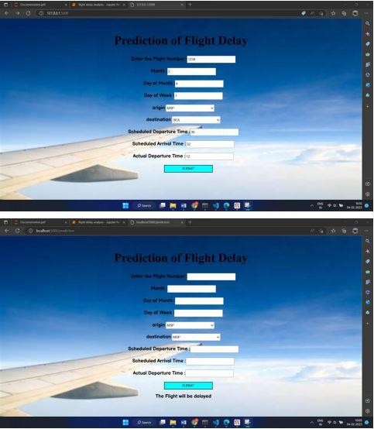

**4. ADVANTAGES & DISADVANTAGES**

**Advantages:**

* Accurate predictions of flight delays
* Early notification of delays to passengers
* Improved on-time performance of airlines
* Better resource management for airlines

**Disadvantages:**

* Model performance may be impacted by unforeseen factors such as sudden weather changes
* High computational requirements for training and prediction

**5. APPLICATIONS**

The machine learning model developed for flight delay prediction can be applied in the following areas:

* Airline scheduling and planning
* Passenger notifications and updates
* Resource management for airlines

1. **CONCLUSION**

In conclusion, the machine learning model developed for flight delay prediction can provide accurate and timely predictions of flight delays, which can help airlines take preventive measures and ensure on-time performance. However, the model's accuracy may be impacted by unforeseen factors, and it requires high computational resources for training and prediction.

1. **FUTURE SCOPE**

The following enhancements can be made in the future:

* Incorporating real-time weather data for improved predictions
* Integrating with airline systems for automatic updates and notifications
* Enhancing the model's computational efficiency

**8. APPENDIX**

**A. Source Code**

#Importing Libraries

from flask import Flask,render_template,request

import pickle

import numpy as np

model = pickle.load(open('flight.pkl','rb'))

app = Flask( name )

@app.route('/')

def home():

return render_template("index.html")

@app.route('/prediction',methods =['POST'])

def predict():

name = request.form['name']

month = request.form['month']

dayofmonth = request.form['dayofmonth']

dayofweek = request.form['dayofweek']

origin = request.form['origin']

if(origin == "msp"):

origin1,origin2,origin3,origin4,orgin5 = 0,0,0,0,1

if(origin == "dtw"):

origin1,origin2,origin3,origin4,orgin5 = 1,0,0,0,0

if(origin == "jfk"):

origin1,origin2,origin3,origin4,orgin5 = 0,0,1,0,0

if(origin == "sea"):

origin1,origin2,origin3,origin4,orgin5 = 0,1,0,0,0

if(origin == "alt"):

origin1,origin2,origin3,origin4,orgin5 = 0,0,0,1,0

destination = request.form['destination']

if(destination == "msp"):

destination1,destination2,destination3,destination4,destination5 = 0,0,0,0,1

if(destination == "dtw"):

destination1,destination2,destination3,destination4,destination5 = 1,0,0,0,0

if(destination == "jfk"):

destination1,destination2,destination3,destination4,destination5 = 0,0,1,0,0

if(destination == "sea"):

destination1,destination2,destination3,destination4,destination5 = 0,1,0,0,0

if(destination == "alt"):

destination1,destination2,destination3,destination4,destination5 = 0,0,0,1,0

dept = request.form['dept']

arrtime = request.form['arrtime']

actdept = request.form['actdept']

dept15=int(dept)-int(actdept)

total = [[name,month,dayofmonth,dayofweek,origin1,origin2,origin3,origin4,orgin5,destination1,destination2

,destination3,destination4,destination5,int(arrtime),int(dept15)]] #print(total)

y_pred = model.predict(total)

print(y_pred)

if(y_pred==[0.]):

ans="The Flight will be on time" else:

ans="The Flight will be delayed"

return render_template("index.html",showcase = ans)

if name == ' main ':

app.run(debug = True)